|  |
| --- |
| Project Understanding |

# Purpose

The goal of the project is to evaluate the structural health of the Ashfork- Bainbridge Steel Dam in order to classify the current hazard potential of the dam.

# Background

The Ashfork-Bainbridge Steel Dam was designed by Francis H. Bainbridge and built in 1898 by the Atchison, Topeka, and Santa Fe Railway Co. The Steel Dam was the first large steel dam in the United States. The dam is located on Johnson Canyon Creek in the Kaibab National Forest, about 40 miles west of Flagstaff, Arizona. The height of the steel dam is about 46 feet, total crest length is about 300 feet and the elevation of dam is 5,402 feet (AzSCE). The materials for the steel frame supports were specified to meet the railway company’s standard specifications for metal bridges. The dam was supported with a series of 24 triangular bents having a slope of 45 degrees facing upstream. It was designed as a cantilever truss with anchorage at the upstream toe. The frames, located on the vertical downstream side, were covered with corrugated plates to keep out spray of the overflow. Rear anchors bolts are two-inch diameter and anchored at right angles to the steel face and two feet into the rock. The bottom plate is anchored to the left abutment. The upstream face is composed of 3/8-inch thick cylindrically curved steel plates riveted to outer flanges of the bent’s I-beams. The top is fitted with curved crest plates, projecting on the downstream side. The flexibility of the curved plates will take up any movement by bending, acting as a suspension system. Expansion joints were provided in the lateral bracing by means of round and slotted holes, with bolts, at connections. Also, the dam has a drainage area of 26 square miles and a gross capacity of 400 acre-feet (Chanson). For additional structural information please see Figure 1 below.

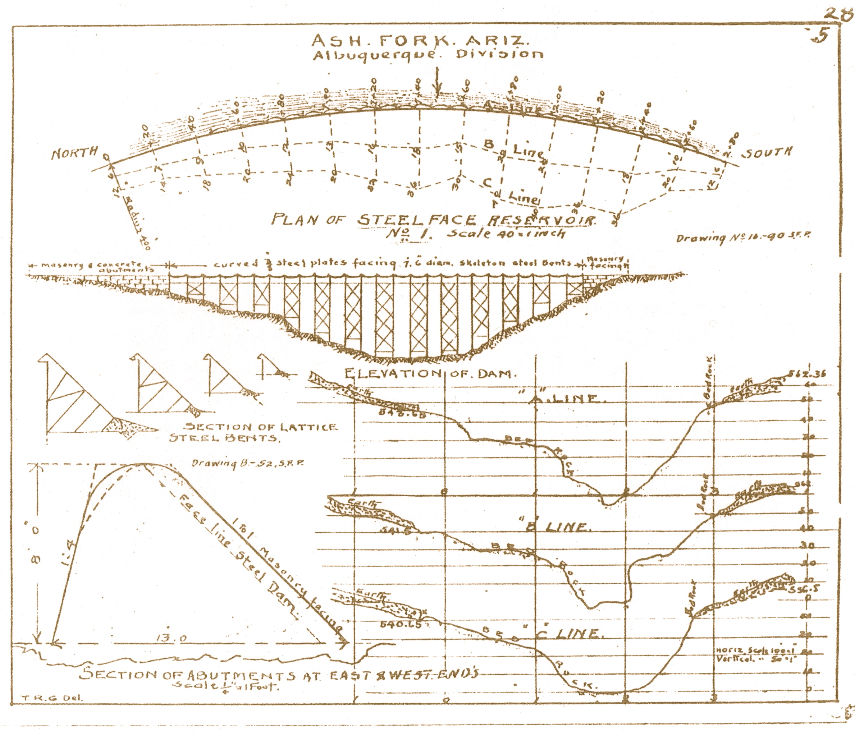

Figure 1: Original drawings of Ashfork-Bainbridge Dam (Bureau of Reclamation)

As shown above, Figure 1 depicts a plan and profile view of the Steel Dam. Cross sections of the steel bents are also shown.

# Stakeholders

The National Forest Service owns and maintains the Steel Dam, which it acquired in 1993. A dam failure could potentially endanger downstream residents of the community of Ash Fork, Arizona and occupants of Monte Carlo Truck Service. Large amounts of runoff from the dam would cross under I-40 through box culverts, maintained by the Arizona Department of Transportation.

# Existing Conditions

The current condition of the Steel Dam is unknown. Studies completed as recent as 2009 rated the dam as low hazard. No maintenance has been performed on the dam in recent years. Recommendations made by previous analyses may be outdated due to changing circumstances.

# Tasks

### Task 1: Identifying Current Conditions:

A site visit will be scheduled to identify any new conditions and to verify known issues make available in previous reports.

Task 2: Analyzing Structural Stability:

Information from the site visit and previous analyses of the dam structure will be used to quantitatively analyze the structure. Use of computer modeling will aid the analysis.

### Task 3: Analyzing Failure Modes:

Based on current conditions, the most feasible failure modes will be defined and ranked by likelihood.

### Task 4: Reevaluation of Hazard Potential:

Analyses will be used to assess the current hazard potential of the dam.

### Task 5: Recommendations:

A plan of action will be given addressing pressing issues. Cost quotes will be provided for severe concerns.

# Timeline

The table below shows when each task will be completed. The tasks are defined previously.

|  |  |  |  |  |  |  |
| --- | --- | --- | --- | --- | --- | --- |
| November | December | January | February | March | April | May |
|  |  | Task 1 |  |  |  |  |
|  |  |  | Task 2 | Task 2 |  |  |
|  |  |  |  | Task 3 | Task 3 |  |
|  |  |  |  |  |  | Task 4 |
|  |  |  |  |  |  | Task 5 |

Task 1 can be completed in one visit to the site. Task 2 will take significantly longer to complete and has been allotted more time for completion. Task 3 can begin near the end of the completion of task 2. Tasks 4 and 5 can be completed simultaneously. All tasks will be completed by May of 2013.

# Potential Challenges

Potential challenges include: modeling the steel dam for analysis, assessing scour on dam, and quoting for accurate cost.

There are only two steel dams in existence in the U.S. Current software and analytical methods are designed for concrete dams. A conservative approach utilizing structural analysis methods will be used to model the dam.

Presence of water on the upstream side of the dam will make it difficult to check extent of scour. Previous reports will be used for scour information. Additionally, evidence of critical scour can be observed on the downstream side of the dam, which is more accessible. If possible, non-destructive methods for evaluating scour can be used.

Few steel dam repairs have been performed, making cost comparisons difficult. Accurate cost estimates will be difficult to attain. Recent cost estimates from maintenance records will be reviewed and changed according to current material costs.

# Key Factors For Success

The key factors for success that DWP Engineering will use are communication, timely completion, and precision. Communication between DWP and client shall be essential to delivering results. All deadlines will be met promptly to deliver timely completion of the project. Finally, attention to detail will provide accurate calculations needed for precision.

**References**

AzSCE. "Ashfork-Bainbridge Steel Dam." *Arizona Society of Civil Engineers – Arizona Section*. Web. 08 Oct. 2012. <http://www.azsce.org/history-steeldam.php>.

Bureau of Reclamation. Technical Service Center. Denver, Colorado. *Comprehensive Dam Evaluation - Steel Dam*. By Terry Payne. Aug 2009. Print.

Chanson, Hubert. "A Brief History of Steel Dams." *History of the Steel Dams*. University of Queensland. Web. 08 Oct. 2012. <http://staff.civil.uq.edu.au/h.chanson/steel_da.html>

**Appendix A – Meeting Minutes**

Meeting with Dr. Robin Tuchscherer

3:00 PM, Wednesday, September 19, 2012

Paul Garrett, Diwei Chen and Wen Cui, the Design Team, met with Dr. Tuchscherer, technical advisor, and began inquiring about the Steel Dam Capstone Project.

The Design Team asked what was required in order to complete the project? Dr. Tuchscherer implied that the Design Team would reconstruct the dam to see if it meets current standards.

Dr. Tuchscherer said much of the project scope depends on what information can be made available to the Design Team by the client, The Forest Service.

Dr. Tuchscherer advised the Design Team to contact the client to set up a meeting in order to define the project scope.

Dr. Tuchscherer provided the Design Team with a contact at the Forest Service. (John O’Brien – [jmobrien@fs.fed.us](mailto:jmobrien@fs.fed.us))

Dr. Tuchscherer suggested the Design Team find out the following information from the client.

-Steel Dam Dimensions

-Material Properties (current)

-Availability of existing drawings, inspection/maintenance reports, engineering documents, hydraulic studies, geotechnical information, etc.

Dr. Tuchscherer said the design team would need to visit project site in order to take pictures, document major rust (not superficial rust), check for section loss and to look for scour.

Dr. Tuchscherer stated that the Design Team could help facilitate analysis (i.e. soil borings). Ideally, the Design team would be able to check stability with the analysis. Also, the Design Team could check for overturning, sliding, and bearing capacity.

The Design Team asked about a budget for the project. Dr. Tuchscherer said that there was no money for a budget.

Dr. Tuchscherer suggested the Design Team consider three possible analysis types hydraulic, structural, and geotechnical. Environmental concerns could also be included.

Dr. Tuchscherer said in the end, the Design Team would give recommendations on how to maintain, repair, or improve the dam.

Dr. Tuchscherer referred the Design Team to Mark Lamer for technical advising for hydraulic analysis aspects of the project.

Dr. Tuchscherer suggested that the ASCE Condition Assessment Guidelines book could help the Design Team with the final deliverable.

End of Meeting - 4:10 PM

Meeting with Steve Hodges

3:00 PM, Friday, September 28, 2012

Paul Garrett, Diwei Chen, and Wen Cui, the Design Team, met with Steve Hodges at the Forest Service building. 1824 S. Thompson St. Flagstaff, AZ 86001.

Steve prepared binders for the Design Team with background information and an outdated emergency action plan from 2008.

Steve explained that the Ashfork-Bainbridge Steel Dam was at one time considered a high hazard dam. An engineering firm did an analysis on the dam and changed its rating to low hazard. There is no longer an emergency action plan in use.

Steve gave background information on the area surrounding the city of Ashfork. There is a dam upstream called Stone Dam, also referred to as Masonry Dam. A high clearance vehicle will be required to visit the site.

Steve referred the Design Team to Edwin Monin, P.E., who will accompany the design team to the dam site.

Steve showed the Design Team a study completed by the State of Arizona. This document was made available to the Design Team, but could not be taken from the Forest Service Building.

Steve showed the Design Team an Operations and Maintenance Manual along with the most recent Inspection Reports. These documents are also available to the Design Team, but cannot leave the Forest Service building.

Steve said no recent maintenance has been completed on the dam and there are likely problems that need to be addressed in the near future.

The Design Team asked if there were any known issues of concern for the dam. Steve said structural degrading, weeping, undermining, and decaying grout cap were some of the main issues.

The Design Team asked for more information on the study that changed the dam to a low hazard rating. Steve found the study, which was performed by JF SATO, and made it available to the Design Team.

The Design Team asked Steve to define the project scope. Steve wants the design team to:

-Look at maintenance records and review known issues that have been identified.

-Visit site and look for further deterioration that might change prioritization.

-Analysis should add value to agency.

-Analysis should confirm/invalidate the aging report.

-Reevaluate and sort priorities of current issues.

-Provide accurate price quotes for pressing issues.

End of meeting – 4:30 PM